Task 1

**1:Ping Command**

After Connecting two pcs With router and when I run the ping command then this Screen is show that How many message are send from one pc to the other pc

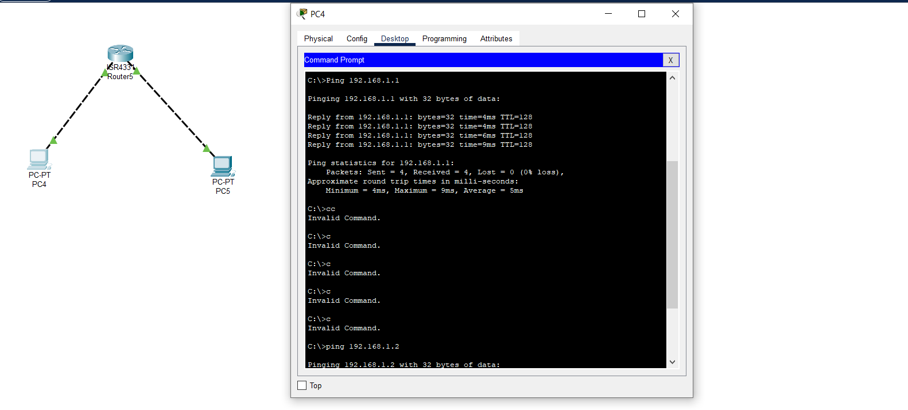

**2:Enable Command**

Enable: Enabling is like unlocking a secret door. It gets you into a special area on a network device where you can make important changes. Think of it as getting permission to access advanced settings.

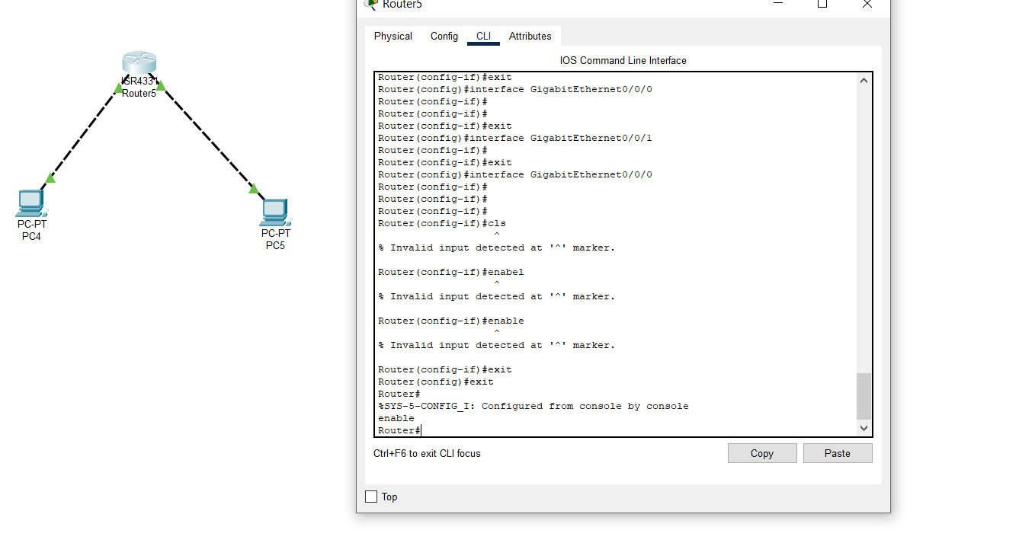

**3:Configure terminal**

Think of configure terminal as entering the control room. where you can change how the device works. Like adjusting settings on a TV, but for network devices.

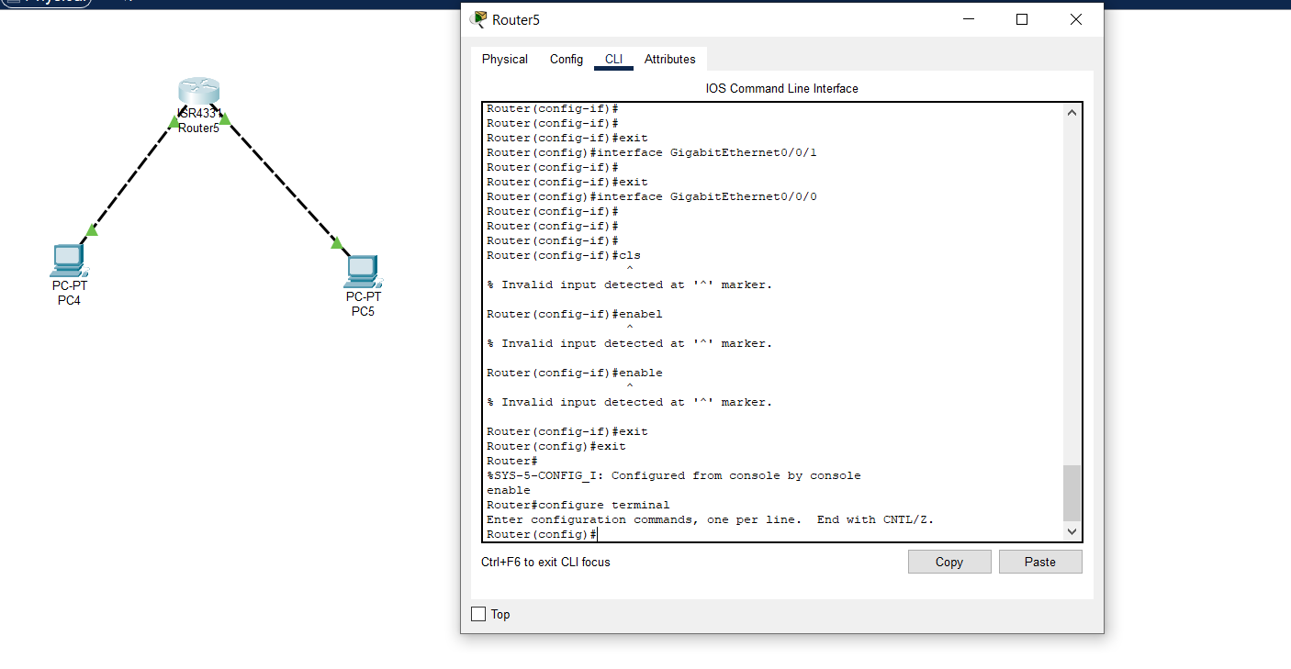

**4:Hostname:**Imagine your computer as a person, and the hostname is their name tag. It&#39;s the device&#39;s name on the network, making it easy to identify among other devices.

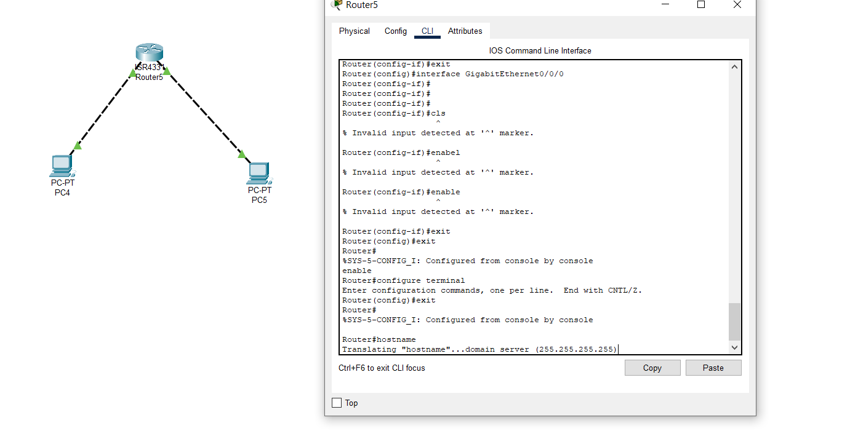

**5:Exit:**When you done in a room, you leave, right? Exit is liket hat. It takes you out of the current mode or place you&#39;re working in, so you can go back to the main menu**.**

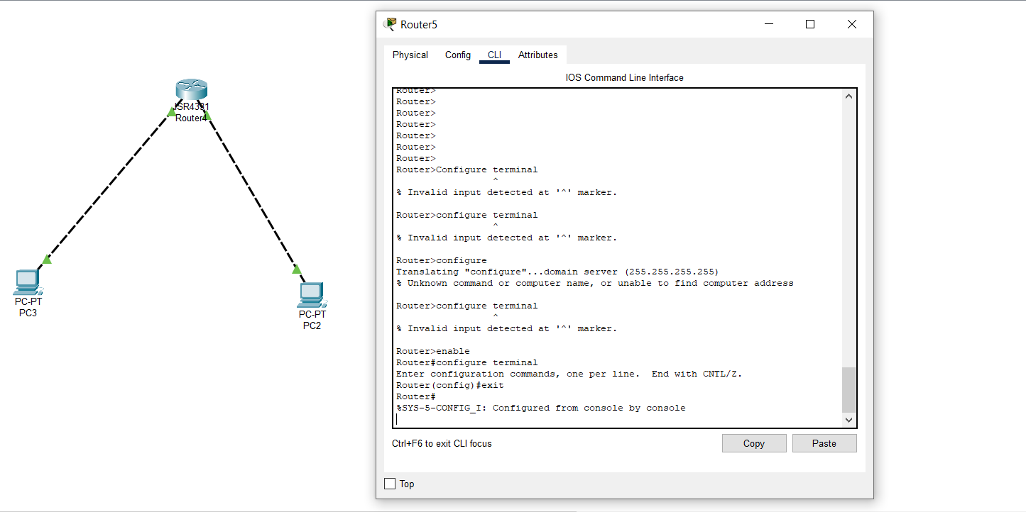

**6:Show Interfaces:**

This command is used to show all the IPS address in the connections

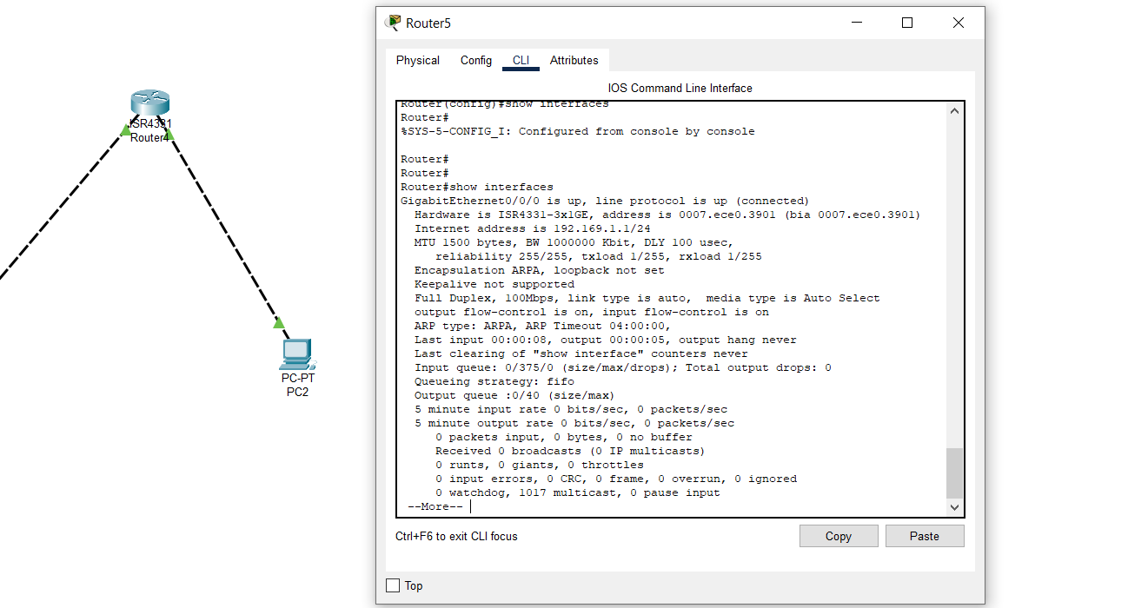

**7:Show IP Interfaces brief:**

This command is used to show all the Ips Adress in the connection to the other connectionIndicates the status of interface. Valid values and their meanings are:

* up—Interface is administratively up.
* down—Interface is administratively down.
* administratively down—Interface is administratively down.

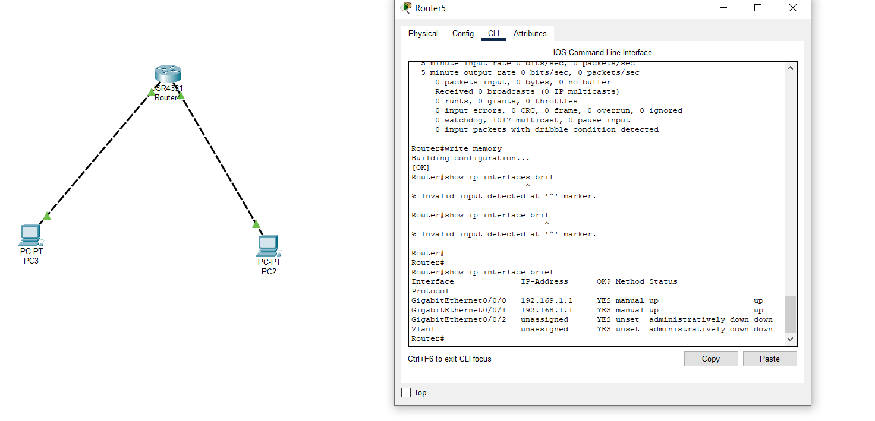**8:Show Vlan:**

The show vlans command lists the VLANs currently running in the switch, with VID, VLAN name and VLAN status.

currently running in the swit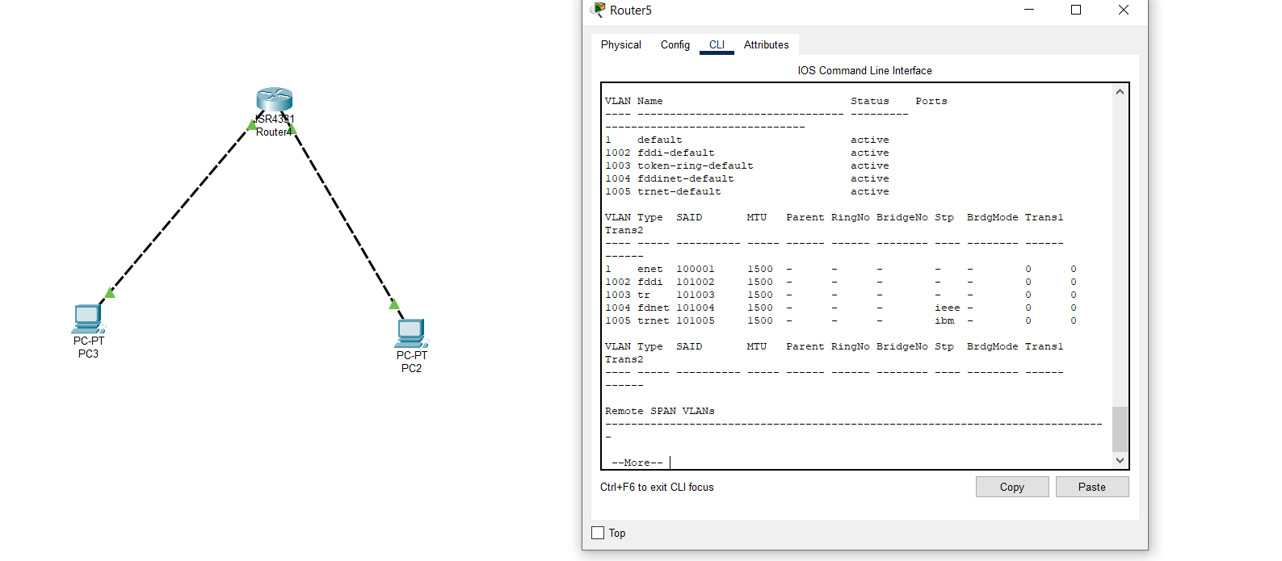

**9:Trace:**

To show Where the IP used in the connection

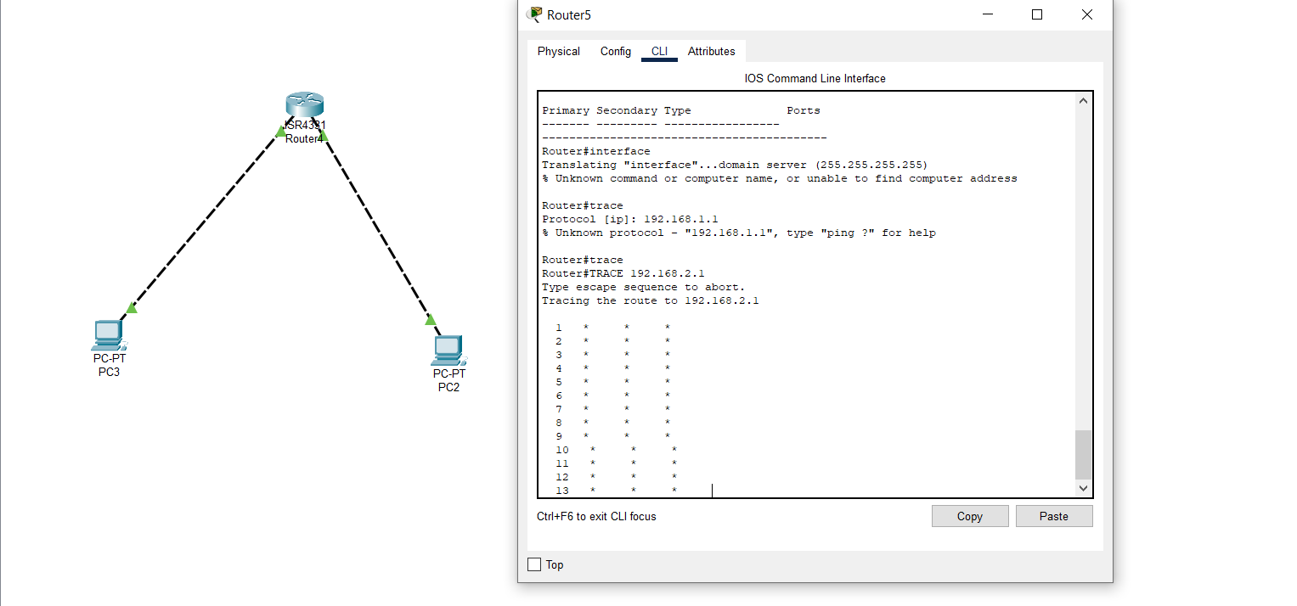

**10:Show IP Routs:**

On a Cisco router, the show ip route command is used to display the IPv4 routing table of a router

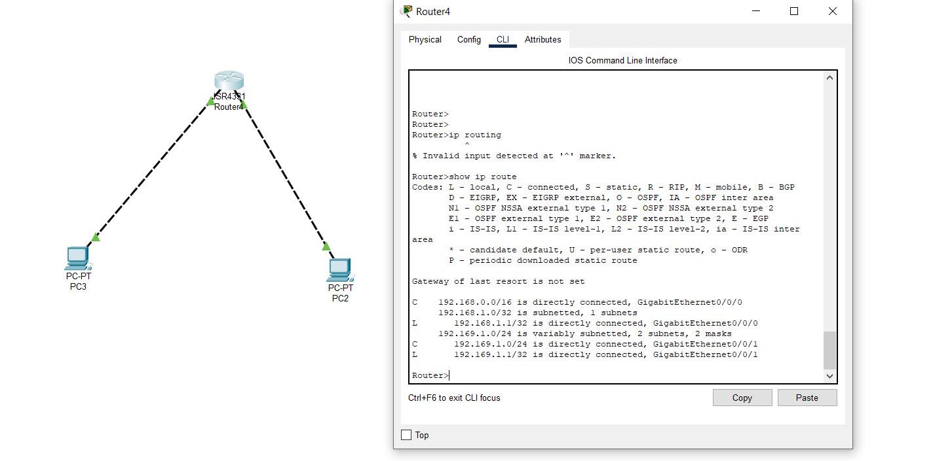

**11:Show Clock:**

This Command is used to show the current time of the device

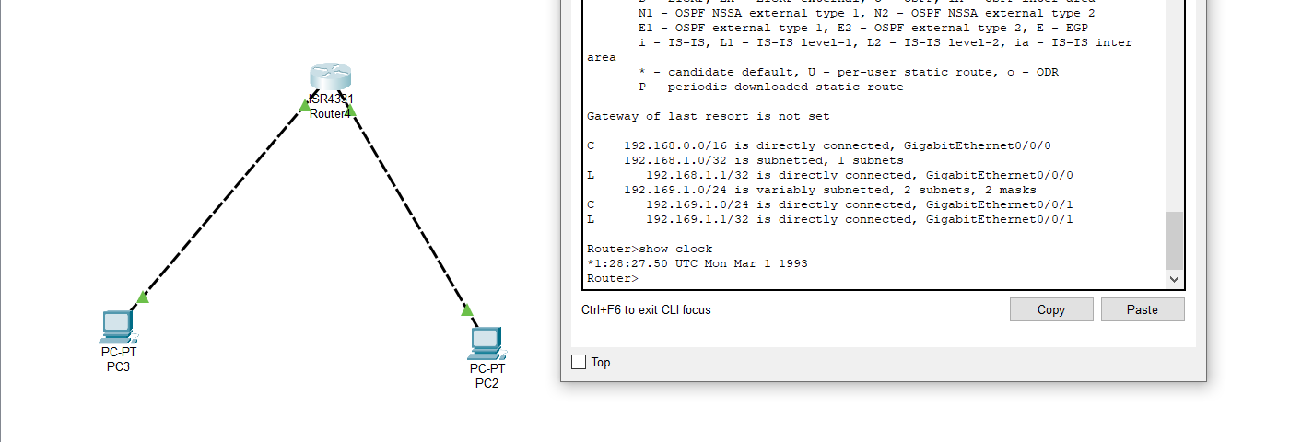

**12:Show flash:**

This is used to show the files in your flash. The command show flash is similar to dir flash: but it provides a little more information on the size and type of flash memory in your router

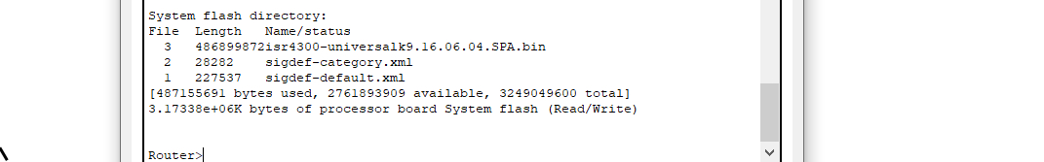

**13:Show Loging:**

To view your switch logs or related configuration information, use any of the following commands:

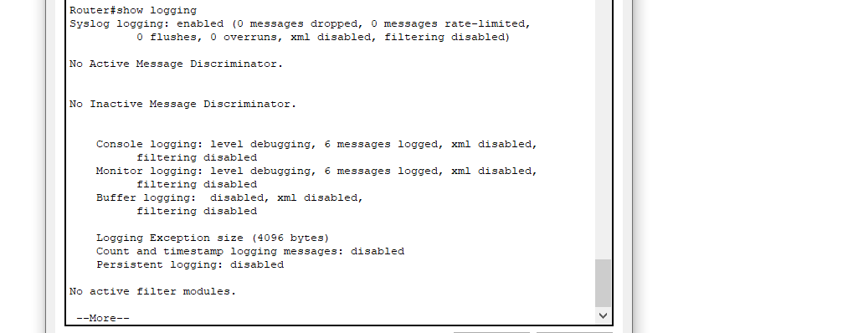

**14:Disable:**

To disable an interface, use the shutdown interface configuration command. To restart a disabled interface, use the no form of this command.



**15:Show User:**

To show how many user are in the current connection

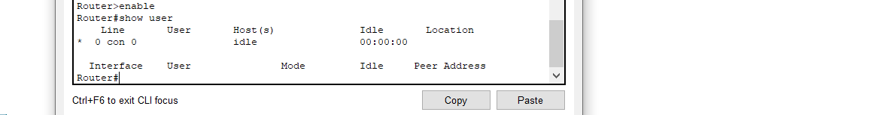

**16:Show Version:**

Displays information about the router's internal components, including the IOS version, memory, configuration register information, etc. The most common use of the show version command is to determine which version of the Cisco IOS a device is running.

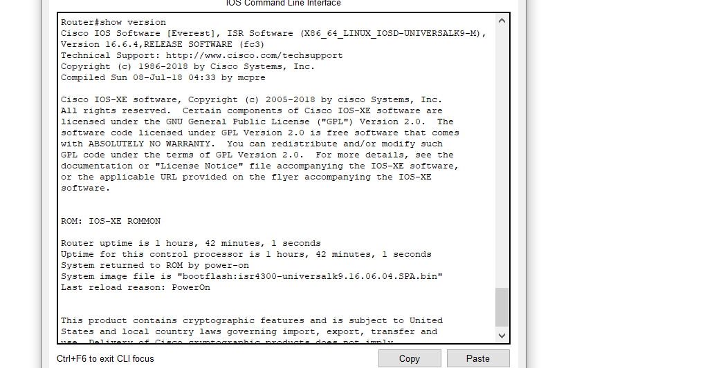

**17:Show ip Routes:**

On a Cisco router, the show ip route command is used to display the IPv4 routing table of a router. A router provides additional route information, including how the route was learned, how long the route has been in the table, and which specific interface to use to get to a predefined destination

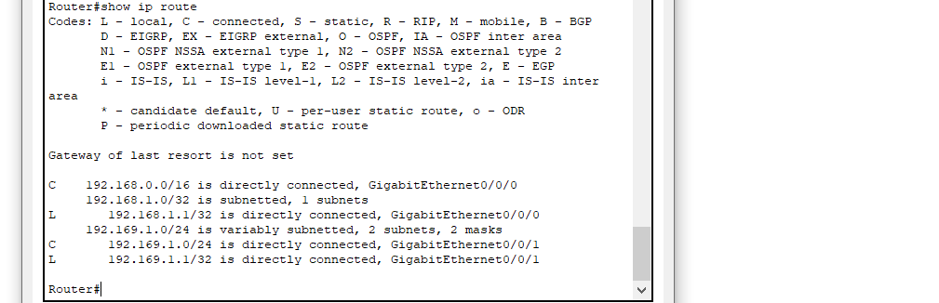

**18:Show running-config:**

The show running-config command displays the current running configuration on the FWSM. You can use the running-config keyword only in the show running-config command. You cannot use this keyword with no or clear, or as a standalone command, because the CLI treats it as a nonsupported command

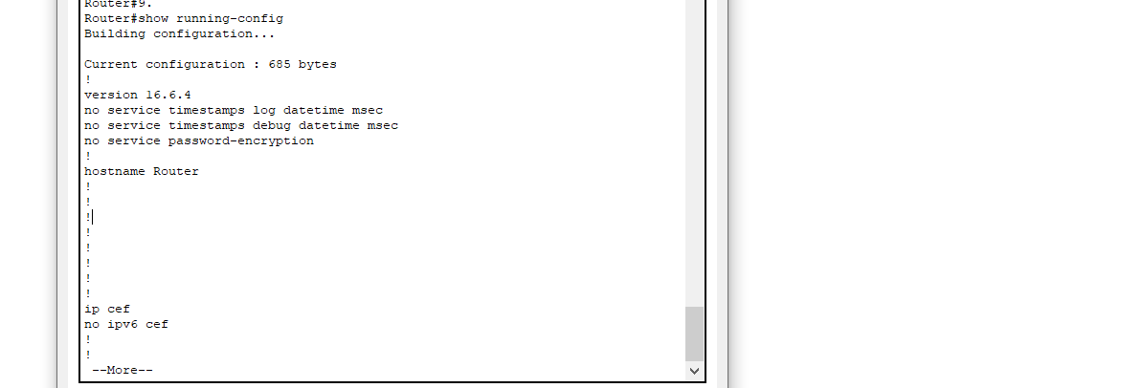

**19:Reload:**

The reload command halts the system. If the system is set to restart on error, it reboots itself. Use the reload command after configuration information is entered into a file and saved to the startup configuration.

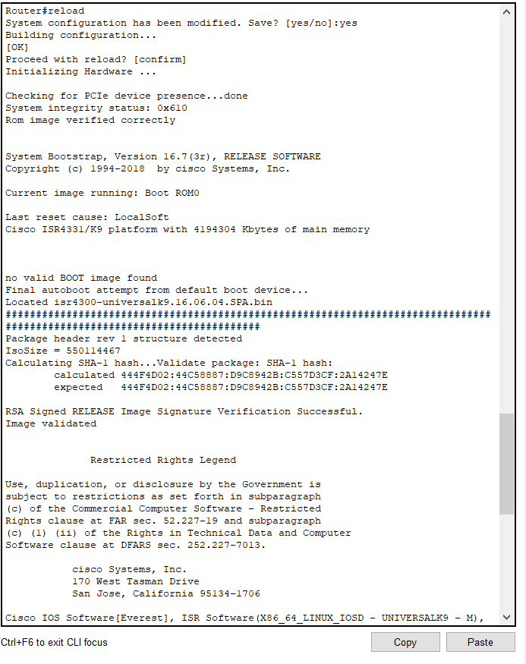

**20:Show Vlans:**

Use the show vlan command to verify your VLAN configuration. This command displays all switchports and their associated VLAN as well as the VLAN status and some extra parameters that relate to Token Ring and FDDI trunks.

